**Experiment No.2**

**Title:** Application of the Agile process models.

**Problem Statement:**

Weather Application Project.

In traditional Waterfall model-

* At a high level, the project teams 20% on project topic and analysis ( 2 weeks)
* 20% of their on design ( 2 weeks)
* 40% on coding ( 5 weeks)
* 20% on system testing( 2 weeks)

The image below shows how these activities align with the project schedule in traditional software development

|  |  |  |
| --- | --- | --- |
| **August** | **September** | **October** |

**Project topic and analysis**

**Test**

**Code**

**Design**

Agile development methodology –

* In the Agile methodology, each project is broken up into several ‘Iterations’.
* All Iterations should be of the same time duration (between 2 to 8 weeks).
* At the end of each iteration, a working product should be delivered.
* In simple terms, in the Agile approach the project will be broken up into 10 releases (assuming each iteration is set to last 4 weeks).
* Rather than spending 1.5 months on requirements gathering, in Agile software development, the team will decide the basic core features that are required in the product and decide which of these features can be developed in the first iteration.
* Any remaining features that cannot be delivered in the first iteration will be taken up in the next iteration or subsequent iterations, based on priority.
* At the end of the first iterations, the team will deliver a working software with the features that were finalized for that iteration.
* There will be 10 iterations and at the end of each iteration the customer is delivered a working software that is incrementally enhanced and updated with the features that were shortlisted for that iteration.

The iteration cycle of an Agile project is shown in the image below

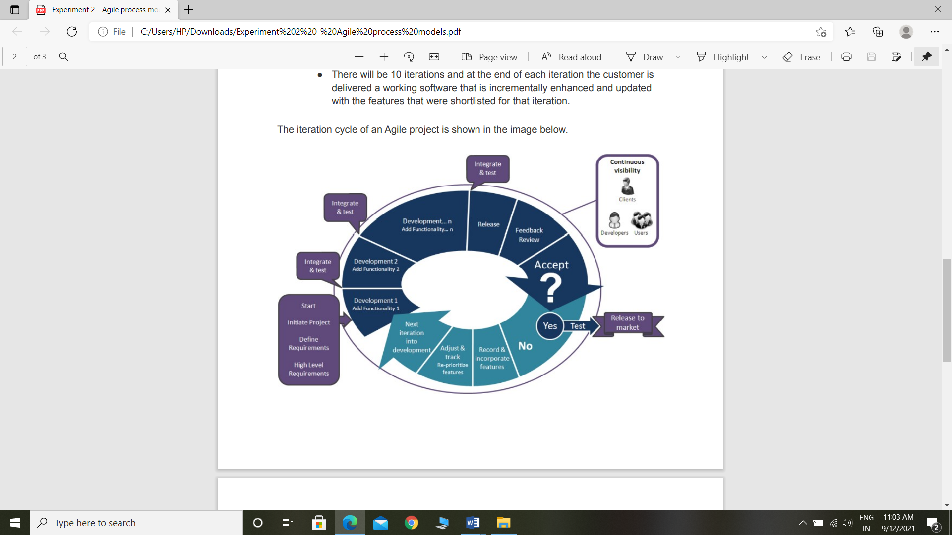

|  |  |  |
| --- | --- | --- |
| **August** | **September** | **October** |

**Learnings**

**User Acceptance**

**Test**

**Code**

**Design**

**Analysis**

**Requirements**

**Requirements**

**Learnings**

**User Acceptance**

**Test**

**Code**

**Design**

**Analysis**

**Requirements**

**Learnings**

**User Acceptance**

**Test**

**Code**

**Analysis**

**Design**

This approach allows the customer to interact and work with functioning software at the end of each iteration and provide feedback on it. This approach allows teams to take up changes more easily and make course corrections if needed. In the Agile approach, software is developed and released incrementally in the iterations. An example of how software may evolve through iterations is shown in the image below.